|  |  |
| --- | --- |
| **Foxdale Primary School**  **Behaviour Policy**     |  | | --- | | Last Review Date: January 2025  Next Review Date: January 2026 | |

**Policy Statement**

Foxdale Primary School is committed to creating an environment where exemplary behaviour is at the heart of productive learning. Everyone is expected to maintain the highest standards of personal conduct, to accept responsibility for their behaviour and encourage others to do the same. Our behaviour policy echoes our core values with a heavy emphasis on respectful behaviour, a partnership approach to managing poor conduct and dynamic interventions that support staff and learners.

Aim of the policy

* To create a culture of exceptionally good behaviour: for learning, for community, for life
* To ensure that all learners are treated fairly, shown respect and to promote good relationships.
* To refuse to give learners attention and importance for poor conduct
* To help learners take control over their behaviour and be responsible for the consequences of it.
* To build a community which values kindness, care, good humour, good temper, obedience and empathy for others.
* To ensure that excellent behaviour is a minimum expectation for all.

Procedures

All staff will :

1. Meet and greet pupils each morning and after every breaktime
2. Model positive behaviours and build relationships
3. Plan lessons that engage, challenge and meet the needs of all learners
4. Use a visible recognition mechanism throughout every lesson
5. Remain calm and consistent in their approach to poor behaviour
6. Follow up any poor behaviour and engage in reflective dialogue with pupils
7. Never ignore or walk past learners who are behaving badly.

The Senior Leadership Team will :

1. Take time to welcome pupils at the start of the day and during transitions
2. Are visible in and around school
3. Support staff in their conversations with badly behaved pupils, and offer support in managing pupils with more complex or negative behaviours.
4. Regularly celebrate pupils whose efforts go above and beyond expectations
5. Encourage use of positive notes and positive phone calls
6. Ensure staff training needs are identified and targeted

Recognition

At Foxdale School we recognise and reward pupils who go ‘over and above’ with their behaviour.

Recognition Boards

Each class has a recognition board with interchangeable class targets on. (*e.g. Good listening, Focus, Resilience) Pupils who achieve the target are praised and consequently have their name written on the recognition board.

*These will be added to as the school develops its’ own Learning Language

Celebration Assembly

Each Friday we have a Celebration Assembly where one child from each year group is chosen as Star of the Week. These children receive a certificate and get to enjoy a comfier seat for the assembly. The certificates are awarded for varying reasons each week; Learning, academic or social progress, demonstrating school values, using our Thinking Moves etc.

Praise

The use of praise is the key to development of positive relationships, including those pupils who are hardest to reach. Teachers praise the behaviour they want to see. Our staff understand that a quiet word of personal praise can be as effective as a larger, more public, reward.

How we manage behaviour

All pupils are held responsible for their own behaviour.

Staff use the steps below to deal with poor behaviour.

|  |  |  |
| --- | --- | --- |
| Step 1  Redirection and Reminder | A reminder of school expectations is delivered privately to the pupil. The teacher makes them aware of their behaviour and the pupil then has a choice to do the right thing. Repeat reminders if necessary.  De-escalate where reasonable and possible and take the initiative to keep things at this stage.  Praise will be given if the learner is able to model good behaviour as a result of the reminder. | |
| Step 2  Caution | A clear verbal caution is delivered privately to the pupil making them aware of their behaviour and clearly outlining the consequences if they continue. The pupil has a choice to do the right thing. Pupils will be reminded of their good previous conduct to prove that they can make good choices.  The learner has a choice to do the right thing. Learners will be reminded of their good previous good conduct to prove that they can make good choices. “Remember when you made a good choice”, “Can you think back to how it felt when you….” | |
| Step 3  Last Chance  (5 minutes after class for restorative conversation/10 minutes in reflection time) | Speak to the pupil privately. Remind them of their previous conduct/attitude/learning. The learner is given a final opportunity to re-engage with the learning / follow instructions  **Use the 30 second scripted intervention** • ​**I have noticed that** ​you are...(having trouble getting started, wandering around etc.) right now. • ​**At Foxdale, we**​... (refer to the school Values – Respect, Honesty, Trust, Kindness) • ​**Because of that you need to...** ​(refer to action to support behaviour e.g. moving to another table, complete learning at another time) • ​**See me for** ​5 minutes after class/during break • ​**Do you remember yesterday/last week when you**​... (refer to previous positive behaviour)? • ​**That is who I need to see today...** • ​**Thank you for listening...** ​then give the child some ‘​**take up’ time**​. If the warning is not heeded and the behaviour continues this must be behaviour)? • ​**That is who I need to see today...** • ​**Thank you for listening...** ​then give the child some ‘​**take up’ time**​. | |
| Step 4  Cool Off | Cool Off might be a short time away from the classroom with another class/TA/nurture room/calm space. It is time allowed to calm down, breathe, look at the situation from a different perspective and compose themselves. | |
| Step 5  Repair / Restorative Conversation | 5 questions is usually enough from the following:   * + What happened?   + What were you thinking at the time?   + What have you thought since?   + How did this make people feel?   + Who has been affected?   + How have they been affected?   + What should we do to put things right?   + How can we do things differently in the future? | |
| Step 6  Consequences | Communication with parent/ carer | If a child has two incidents in a week requiring reflection the class teacher must inform parents. This must be recorded on Arbor. |
| A formal meeting with SLT and parents/carers. | If a child has three or more incidents in a week (or regular incidents) requiring reflection a meeting with SLT and parents/carers will be arranged. This must be recorded on Arbor. |
| Weekly behaviour meetings | Children who regularly receive more than 3 reflections in a week will have weekly monitoring meetings (during lunchtime) to discuss their behaviour. |
| Exclusion | A serious breach may lead to a fixed term exclusion. |

Pupils may have their behaviour monitored by teachers to show progress towards agreed targets. At Foxdale Primary we make sure that this is done discreetly. We do not advertise poor behaviour to other learners or give fame to those who choose not to meet our high standards of behaviour.

Further information on Step 5

Restorative conversations at Foxdale are a core part of repairing damage to trust between staff and learners. A restorative meeting should take place before the next lesson.

**Definition**

The aim of restorative practices is to develop community and to manage conflict and tensions by repairing harm and building relationships.

**Restorative Practices in Schools is about:**

• building safer schools  
• changing behaviour not punishing  
• adults modelling restorative approaches  
• finding ways to repair harm  
• supporting staff, children and families to use RP to build community

**Why use a restorative approach?**

• Punishment doesn’t meet needs of those who suffered  
• May be kudos or ‘street cred’ attached to the punishment  
• Offenders don’t have to face full effects of actions  
• Offender may feel isolated and it may be difficult for them to get back into school  
community, making rule-breaking more attractive  
• If problem behaviour persists, child may be pushed down a road of exclusion and marginalisation. They may be removed from school, but remain a problem in the wider community

**Restorative Questions 1**

To respond to challenging behaviour:  
• What happened?  
• What were you thinking about at the time?  
• What have your thoughts been since?  
• Who has been affected by what you did?  
• In what way have they been affected?  
• What do you think you need to do to make things right?

**Restorative Questions 2**

To help those harmed by others’ actions:

* What did you think when you realised what had happened?
* What have your thoughts been since?
* How has this affected you and others?
* What had been the hardest thing for you?
* What do you need to do to make things right?

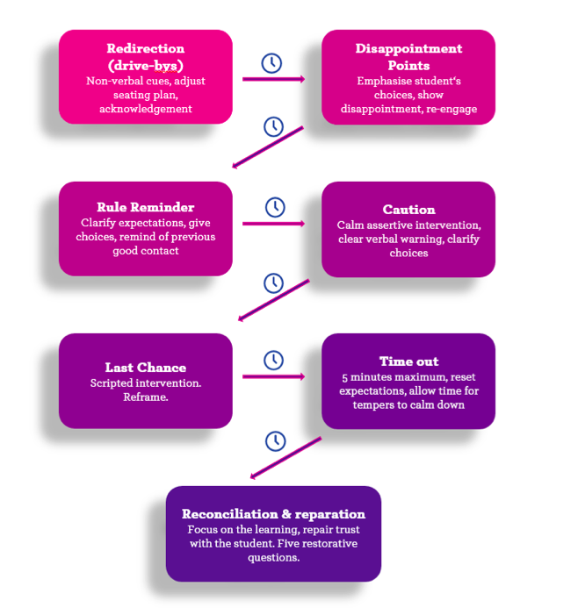

Policy Review

Date of Last Review: September 2025

Date of Next Review: September 2026

