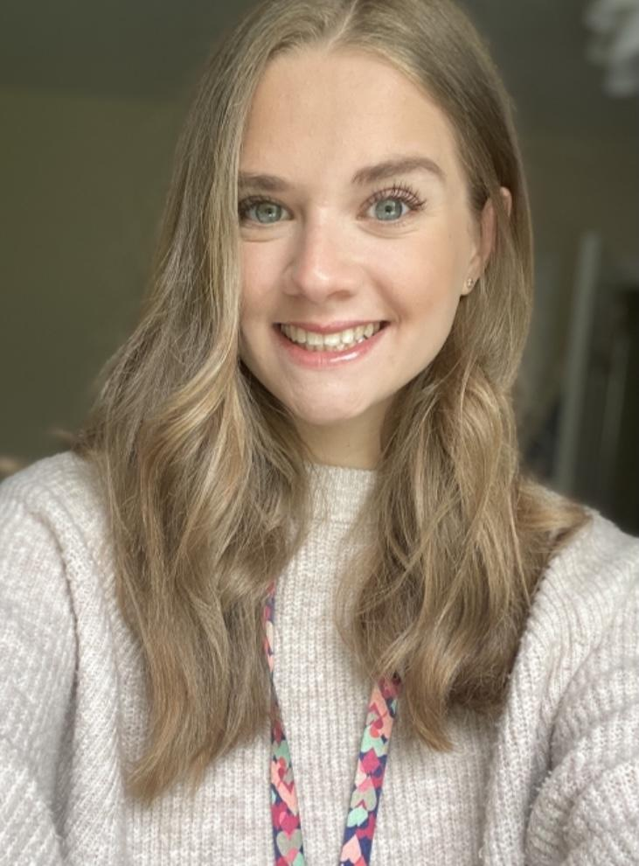
Dear Parents and Carers,

My name is Miss Longshaw and I am a trainee teacher in Reception - Cronk Vane for the period March to June 2021. I am currently a postgraduate student at Edge Hill University undertaking the Early Years PGCE with QTS.

I will be working with Miss Davies and Miss Sayle to plan and deliver lessons to your children. Prior to this placement, I have had experience in pre-schools, primary schools and a secondary school in the IOM and UK.

I am grateful to have met all the children in Cronk Vane before lockdown began and I am looking forward to the rest of my placement. I hope to inspire your children on my teaching journey and provide them with enjoyable and engaging learning experiences.

I look forward to meeting you all.

Kind regards,

Miss N. Longshaw.

